MSC MALAYSIA – IHL BUSINESS PLAN COMPETITION 2009/10 CONFIDENTIAL

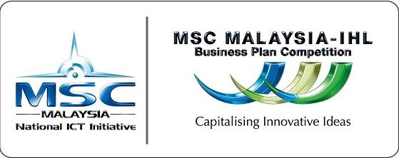

BUSINESS PLAN

[Version 2.1/020709/TED/MDeC]

Title of Business Plan :

Name of Team:

Executive Summary |  | / | 15 | A
Company Intro |  | / | 15 | A
Business Model & Description |  | / | 10 | C
Employment of Knowledge Workers |  | / | 10 | A
Product/Service Development |  | / | 15 | B
Marketing Programs |  | / | 20 | B
Financial Projections (Capital Requirement, Sales & R&D) |  | / | 10 | A
Conclusion / Appendices |  | / | 3 | A
CD Attached (Labelled with Student Name, Course, Tutorial Group) |  | / | 2 | A
TOTAL |  | / | 100

Section Summary
A |  | / | 55
B |  | / | 35
C |  | / | 10

COURSE : Software Engineering

Names of Individuals :
- William Huang <Tutorial Group> <Student Id>
- <Student name 2> <Tutorial Group> <Student Id>
- <Student name 3> <Tutorial Group> <Student Id>
- <Student name 4> <Tutorial Group> <Student Id>
- <Student name 5> <Tutorial Group> <Student Id>


Multimedia Development Corporation Sdn. Bhd. (389346.D)

MSC Headquarters, 2360 Persiaran APEC, 63000 Cyberjaya, Selangor Darul Ehsan, Malaysia. Telephone: +603 8315 3000 Fax: 603 8318 7612 URL: www.mscmalaysia.my
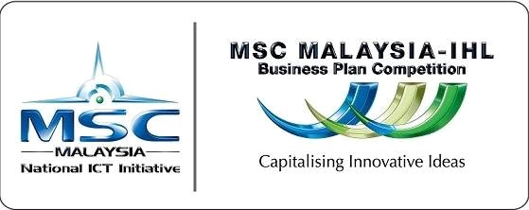
 |  |  |  |  |  | CONFIDENTI AL
 | Team Advisor Contact Details
 | No. | Advisor Name | Designation | Faculty | Email |  | Mobile

Team Members Contact Details

No. | Team Name | Course | Faculty | Email | Mobile

Multimedia Development Corporation Sdn. Bhd. (389346.D)

MSC Headquarters, 2360 Persiaran APEC, 63000 Cyberjaya, Selangor Darul Ehsan, Malaysia. Telephone: +603 8315 3000 Fax: 603 8318 7612 URL: www.mscmalaysia.my
CONFIDENTI AL

Declaration by Team Advisor – Pls. check all of the boxes provided below.

I hereby declare that the business plan submitted by the team is original and is derived from their own thoughts/study/research.

I have done the necessary due diligence check via the internet and other sources/media to ensure that the business plan was not plagiarized from other sources/media.
I hereby verify that this business plan has not been commercialized by the team at the point of submitting this proposal.

I agree for the submission to be disqualified if any of the above statements are found to be untrue.

Signature :


Name :

Date :

Multimedia Development Corporation Sdn. Bhd. (389346.D)

MSC Headquarters, 2360 Persiaran APEC, 63000 Cyberjaya, Selangor Darul Ehsan, Malaysia. Telephone: +603 8315 3000 Fax: 603 8318 7612 URL: www.mscmalaysia.my
CONFIDENTI AL

Declaration by Team Members – Pls. check all of the boxes provided below.

I/We hereby declare that the business plan submitted by me/us is original and is derived from my own/our thoughts/study/research.
I/We have done the necessary due diligence check via the internet and other sources/media to ensure that the business plan was not plagiarized from other sources/media.
I/We hereby verify that this business plan has not been commercialized at the point of submitting this proposal.
I/We agree for the submission to be disqualified if any of the above statements are found to be untrue.
Signature:


Team Member

Name:

Date :

Signature :

Team Member

Name:

Date :

Signature :

Team Member

Name:

Date :

Multimedia Development Corporation Sdn. Bhd. (389346.D)

MSC Headquarters, 2360 Persiaran APEC, 63000 Cyberjaya, Selangor Darul Ehsan, Malaysia. Telephone: +603 8315 3000 Fax: 603 8318 7612 URL: www.mscmalaysia.my
CONFIDENTI AL
Contents
Section 1.0 EXECUTIVE SUMMARY………………………………………………. | 1
Section 2.0 INTRODUCTION TO THE COMPANY………………………………. | 1
2.1 Company Background………………………………………………….. | 1
2.2 Business Intent………………………………………………………….. | 1
2.3 Growth Strategies……………………………………………………….. | 1
2.3.1 Financial Strategies………………………………………….. | 1
2.3.2 Technology and Product Development Strategies………… | 1
2.3.3 Marketing Strategies to increase market or mind share….. | 1
2.4 Target Markets………………………………………………………….. | 2
2.5 Revenue Model…………………………………………………………. | 2
2.6 Operational Setup………………………………………………………. | 2
2.7 Long Term Goals of company…………………………………………. | 2
2.8 Market & Competitors Information……………………………………. | 2
2.9 Strength & Weaknesses or SWOT (if possible)……………… ……… | 2
2.10 Business Model and Description……………… ……………………. | 2
Section 3.0 EMPLOYMENT OF KNOWLEDGE WORKERS…………………… | 2
3.1 Management Team…………………………………………………….. | 2
3.2 Organizational Chart………………………………………………....... | 3
3.3 Human Resource Plan………………………………………………… | 3-4
Section 4.0 PRODUCT OR SERVICE DEVELOPMENT………………………… | 4
4.1 Product / Service / Technology Overview…………………………….. | 4
4.2 Research and Development (R&D)……………………………………. | 4
4.3 Benefits & Customer Value…………………………………………….. | 4
Section 5.0 MARKETING PROGRAMS…………………………………………… | 5
5.1 Marketing Overview……………………………………………………. | 5
5.2 Marketing Programs……………………………………………………. | 5
Section 6.0 FINANCIAL PROJECTIONS…………………………………………. | 5

- Financial Overview……………………………………………………. 5

- Financial Qs to consider………………………………………………. 5-6

Section 7.0 CONCLUSION or APPENDICES…………………………………… 6

Multimedia Development Corporation Sdn. Bhd. (389346.D)

MSC Headquarters, 2360 Persiaran APEC, 63000 Cyberjaya, Selangor Darul Ehsan, Malaysia. Telephone: +603 8315 3000 Fax: 603 8318 7612 URL: www.mscmalaysia.my

CONFIDENTI AL
Section 1.0 EXECUTIVE SUMMARY

The executive summary is an independent element of the business plan. It should contain a brief overview of the most important aspects of the business plan. In particular, it should highlight the product or service, the value to the customer, the relevant markets, management expertise, financing requirements, and possible return on investment.

The reader should be able to read and comprehend the summary in ten minutes.
___________________________________________________

Section 2.0 INTRODUCTION TO THE COMPANY

- Company Background

- Business Intent & Clear indication of intended business activities.

- Growth Strategies

Should the company applying is an existing operation, please describe the history of its activities, or if the applying company is a JV Co. describe as well the nature of the partnership and its shareholding interest.

___________________________________________________

Please describe clearly the intended business activities of your company. A point-by-point description of the activity is highly encouraged. Details of the activities would be enumerated in

Section 4.1 Product or Service development.

An acceptable business intent write- up should consist of the following four elements (1) Product or services offered (2) market need (3) degree of innovation (4) feasibility and profitability.

___________________________________________________

State what are the strategies that your company plans to deploy or achieve in growing the company. E.g.

2.3.1 Financial Strategies

The project is to be funded by Venture Capital Financing To maximize the project value and image by Initial Public Offering (IPO) and listing the company in any technology based exchanges such as MESDAQ.

2.3.2 Technology and Product Development Strategies

To have flawless mobilization

To rapidly deploy the system integration by initially To understudy closely with the……

To invest consistently in potential experts.
To develop smart partnership with ….
To exploit the ready infrastructure
To extend into developing ……
To exploit the database for ……

1
Multimedia Development Corporation Sdn. Bhd. (389346.D)

MSC Headquarters, 2360 Persiaran APEC, 63000 Cyberjaya, Selangor Darul Ehsan, Malaysia. Telephone: +603 8315 3000 Fax: 603 8318 7612 URL: www.mscmalaysia.my

CONFIDENTI AL

- Target Markets

- Revenue Model

- Operational Setup

2.3.3 Marketing Strategies to increase market or mind share.

To have flawless mobilization

___________________________________________________

State the target audience of your product or services.

___________________________________________________

Describe how your company would earn revenue either from products, services, JV-collaborations, etc
___________________________________________________

Describe the extent of operational setup that your company would be undertaking.
___________________________________________________

2.7 Long Term Goals of | What is the aspiration of the company in the next 3 years at
company | What is the aspiration of the company in the next 3 years at
company | least? Where does management see the company heading?
 | ___________________________________________________

2.8 Market & Competitors

Information

2.9 Strength & Weaknesses or SWOT (if possible)

2.10 Business Model & Description

Describe the market segment or target market you are in. Also, indicate which main factors are now influencing or may influence the given industry segment. Show what factors will affect developments (technology, legislative initiatives, etc.) and what relevance these factors have for your business.

Define the strengths and weaknesses of your competitors. Evaluate your major potential competitors using the same criteria, e.g. sales volume and revenues (pricing), growth, market share, cost positioning, product lines, customer support, target groups, and distribution channels.

Evaluate your own company according to these same criteria, and make a comparison as to how sustainable your competitive advantage will be.

___________________________________________________

Broadly, list the competitors in your market segment, and briefly describe the strength and weaknesses against your product or services.

___________________________________________________

Produce a conceptual structure supporting (i.e. picture representation) the viability of the business idea. Briefly describe the rational of how the business idea creates, delivers, and captures value in economic, social, cultural or other contexts. Explain the aspects of a business (e.g. business process, target customers, offerings, strategies, infrastructure etc.)
___________________________________________________

2
Multimedia Development Corporation Sdn. Bhd. (389346.D)

MSC Headquarters, 2360 Persiaran APEC, 63000 Cyberjaya, Selangor Darul Ehsan, Malaysia. Telephone: +603 8315 3000 Fax: 603 8318 7612 URL: www.mscmalaysia.my

CONFIDENTI AL

SECTION 3.0 EMPLOYMENT OF KNOWLEDGE WORKERS

3.1 Management Team

3.2 Organizational Chart

3.3 Human Resource

Plan

The management section is often the essential part of the plan.

Elements that we look for are:
• Education background
- • Experience or involvement in the industry
• Designation and Role in the applying company

It would be good if you could provide a brief resume of the key management staff.
___________________________________________________

Sample of an organizational structure can be shown as follows:
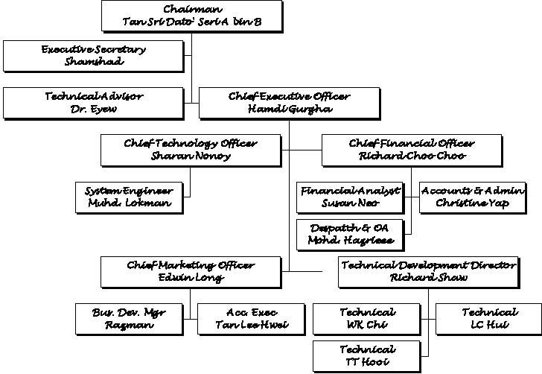

___________________________________________________

Describe the type of people, expertise and training that your company has planned for the staff.

Please fill in 3 year projected human resource plan, segregated by knowledge and non-knowledge (support) staff. Example in table below:

 | Position/Role |  | Y1 | Y2 |  | Y3
 | Chairman/CEO |  | 1 | 1 |  | 1
 | Chairman/CEO |  | 1 | 1 |  | 1
 | CEO |  | 1 | 1 |  | 1
 | Technical Advisor |  | 1 | 1 |  | 1
 | Executive Secretary |  | 1 | 1 |  | 1
 | Position/Role |  | Y1 | Y2 |  | Y3
 | Technical Division
 | CTO
 | Technical Development
 | Director
 | Technical Consultant
 | System Engineer
 | Technical Engineer
 |  |  |  |  |  | 3
Multimedia Development Corporation Sdn. Bhd. (389346.D)
MSC Headquarters, 2360 Persiaran APEC, 63000 Cyberjaya, Selangor Darul Ehsan, Malaysia.
Telephone: +603 8315 3000 Fax: 603 8318 7612 |  | URL: www.mscmalaysia.my

CONFIDENTI AL


Bus. Dev. Division
CMO
Business Development

Manager

Account Executive

Finance and Admin.

CFO

Financial & Admin.

Assistant

Dispatch & Office

Assistant

Total No. Of Worker

Total Knowledge

Workers

Total Foreign Knowledge

Workers

% Of Knowledge workers

Section 4.0 PRODUCT OR SERVICE DEVELOPMENT

4.1 Product / Service /

Technology Overview

4.2 Research and

Development (R&D)

4. 3 Benefits & Customer

Value

This section should explain the nature, extent of design, development or establishment of your products and services over both the short and long term.

Essentially, the following are good elements to include:

- Core technologies
- Current development or R&D status
- Product strategy for current or future products
- Intellectual property

This is a KEY section, where you describe the technologies, services and solutions that your company is best at, and central to the success of your business.

___________________________________________________

Forecast Development as part of solution improvement or technology Change

Also if possible describe R&D Strategies and Milestones

___________________________________________________

Your innovative product or services should have its benefits to the end customer. It is important to indicate how your product differs from others that are now or will be on the market.

Discuss the function of your product or services and the value in which the customer will gain from it.

4
Multimedia Development Corporation Sdn. Bhd. (389346.D)

MSC Headquarters, 2360 Persiaran APEC, 63000 Cyberjaya, Selangor Darul Ehsan, Malaysia. Telephone: +603 8315 3000 Fax: 603 8318 7612 URL: www.mscmalaysia.my

CONFIDENTI AL

If comparable products, technology or services are already available from your competitors you must convincingly substantiate the added value your customers will receive. If you are offering a range of innovative products or services, categorize them and describe how the integrated products will benefit consumers.

___________________________________________________

Section 5.0 MARKETING PROGRAMS

5.1 Marketing Overview This section should describe how the sales projections you are making in your financials will be attained in terms of positioning, marketing activities and promotional campaigns.

 | This section is actually a representation of the overall content of
 | your more detailed company Marketing plan, only in a much
 | more condensed fashion.
 | ___________________________________________________
5.2 Marketing Programs | It should include:

- Your overall marketing strategies, incl. Events, materials and primary tactics
- Your pricing strategy (this could also be covered in Revenue Model segment)
- Your marketing and sales messages
- Your promotional strategy
___________________________________________________

Section 6.0 FINANCIAL PROJECTIONS

6.1 Financial Overview This section represents the conservative, achievable and management projections of revenue, cost, expenses and cash flow.

6.2 Financial Qs to consider
For convenience, you are suggested to use the samplefinancial template given to you by the MSC Assessor.

These includes

- P&L projections for 3 years (in RM)

- Cash flow projections for 3 years (in RM)
- Performa Balance Sheet for 3 years (in RM)
- Major capital requirements or expenditure
- Breakdown of sales (in detail)
- Breakdown of R&D expenditure in detail
- Last 3 Years Revenue and Profit after tax (should your company already been in operation the last 3 years)
___________________________________________________

Key questions that can be observed:

5

Multimedia Development Corporation Sdn. Bhd. (389346.D)

MSC Headquarters, 2360 Persiaran APEC, 63000 Cyberjaya, Selangor Darul Ehsan, Malaysia. Telephone: +603 8315 3000 Fax: 603 8318 7612 URL: www.mscmalaysia.my

CONFIDENTI AL

- How will your revenues and expenses develop?

- What assumptions underlie your financial planning?
- What sources of capital are available to you to sustain operations?
- How will you realize profits?
- What can an investor expect should they invest in your company?

By adopting the above program it is expected that the usage of XYZ SB products and services will exhilarate. It is foreseen that the provision of the gateway and the services by XYZ SB will accelerate the development of mobile commerce and E-business in various economic and business environment in Malaysia that will contribute to the development of multimedia and IT business.

___________________________________________________

Section 7.0 CONCLUSION or APPENDICES

Everything else that you wish to include.

___________________________________________________

6
Multimedia Development Corporation Sdn. Bhd. (389346.D)

MSC Headquarters, 2360 Persiaran APEC, 63000 Cyberjaya, Selangor Darul Ehsan, Malaysia. Telephone: +603 8315 3000 Fax: 603 8318 7612 URL: www.mscmalaysia.my

